***­­­environmental SCIENTIST*  journal: Learning Resource Notes**

The purpose of these educational resource notes is to provide a format for informal, seminar-style discussions of the topics explored in the latest edition of the journal of the Institution of Environmental Sciences.

Through discussion of the ideas and issues presented within the journal, they aim to supplement and enhance students’ knowledge and understanding of a broad range of environmental science issues and provide insights into the professional concerns of practising environmental scientists.

**Articles in focus**

The below articles have been selected as particularly relevant for in-depth discussion, allowing for wider debate of the key elements of the article topic. Some specific questions you may wish to consider when reading and discussing these articles are outlined.

|  |  |
| --- | --- |
| Learning outcomes | * Understand the main concepts and challenges discussed in the edition * Describe the conclusions reached by authors, and identify their relevance to the environmental science sector * Critically reflect on the ideas presented |
| Format | * Articles of particular interest are to be selected and shared with the group to read ahead of the discussion. Suggestions of focus articles are described below. * Small group discussions of articles that closely relate to programme content to supplement learning. * Discussions can be led by participants or the tutor, using the ‘articles in focus’ resource to prompt debate and aid the conversation. * The suggested discussion points and questions provided in this pack for selected articles can be used as a starting point to guide the discussion. * Students can be encouraged to choose to discuss any of the other articles within the issue. |

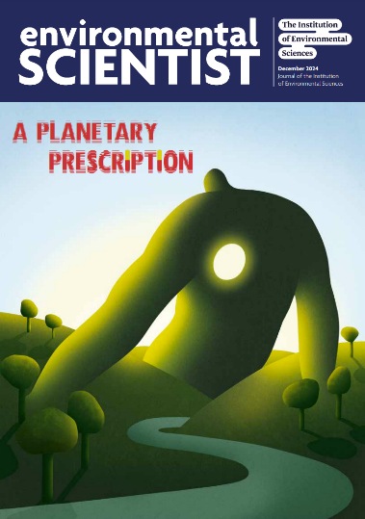e*nvironmental SCIENTIST* **A Planetary Prescription**Vol 34, issue 4

https://www.the-ies.org/resources/planetary-prescription

|  |  |
| --- | --- |
| **Topic overview** | This issue of environmental SCIENTIST sheds light on the ways in which human health and the environment are inextricably linked.  Articles explore the complexities of well-known issues such as PFAS contamination and air pollution, alongside topics including inequitable access to healthcare and the green spaces necessary for wellbeing, the impacts of heat stress on maternal health, and the health effects of increasing mould and fungus in UK housing due to climate change.  This edition will ultimately raise important questions about the unevenly distributed effects of environmental damage on human health, and propose ways to address these imbalances head-on.  Contributors in this issue respond to the health impacts of both systemic and specific environmental crises, driving forward thinking around how we respond holistically to the countless health challenges global society is facing, particularly those that are intensified by climate change and its multifaceted effects. |
| **Articles in focus** | |
| **‘A natural health service for the 21st century?’**  **(Dom Higgins, p. 16)** | **Article overview:** This article considers the outcomes of a recent government-funded green social prescribing programme with the Wildlife Trusts. |
| * What kinds of health problems can green prescribing help to alleviate? * Discuss the process of green prescribing, and how it operated with the NHS under the programme. * Assess the value of green social prescribing to people who are at an economic and social disadvantage in the UK, and the knock-on effect this could have within the NHS. |
| **‘PFAS: health and policy impacts in the UK’**  **(Stephanie Metzger, p. 56)** | **Article overview:** In this article, the author explores the policy landscape of the UK in relation to the regulation of PFAS chemicals. |
| * What are PFAS chemicals, and how can they be categorised? * Explain why the current regulatory UK frameworks are struggling to manage the spreading of PFAS in our environment. * Discuss the reasons why the health concerns of some PFAS chemicals are difficult to evaluate. |
| **‘Air pollution and environmental justice in the UK’ (Jo Barnes p. 68)** | **Article overview:** This article examines the intersections of air pollution distribution and environmental justice across the UK, and how impacts of air pollution can be mitigated. |
| * What is the fundamental problem with applying the same air quality policy to all members of society, irrespective of their social group? * After reading pages 70 and 71 of this article, debate with another person whether the unequal distribution of air pollution in the UK is just or unjust. * Evaluate the problems with air pollution and environmental justice studies that focus on a single pollutant. |